ការរៀបចំ Admin Page តាមគំរូ Layout ខាងក្រោម៖

|  |  |
| --- | --- |
| header.php | |
| nav.php | |
| sidebar.php | content.php |
| footer.php | |

១.​បង្កើត​ files

* index.php : ជា file រួម​សម្រាប់គ្រប់គ្រងលើ​ file ទាំងអស់ បានន័យថា​ file ទាំងអស់​ត្រូវ​ include បញ្ចូល​ក្នុង​ file index.php តែមួយ។
* header.php
* nav.php
* sidebar.php
* footer.php
* content.php

មើលលក្ខណៈនៃ files ក្រោយបង្កើត​រួចក្នុង​ folder : crud_admin

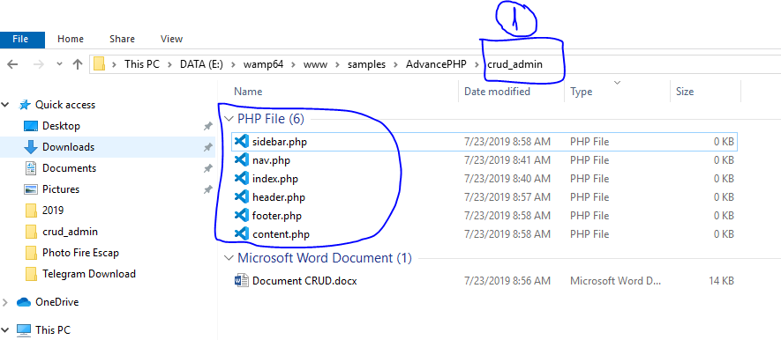

២.​សរសេរកូដក្នុង​ files និមួយៗ

ក.​កូដក្នុង​ file : index.php

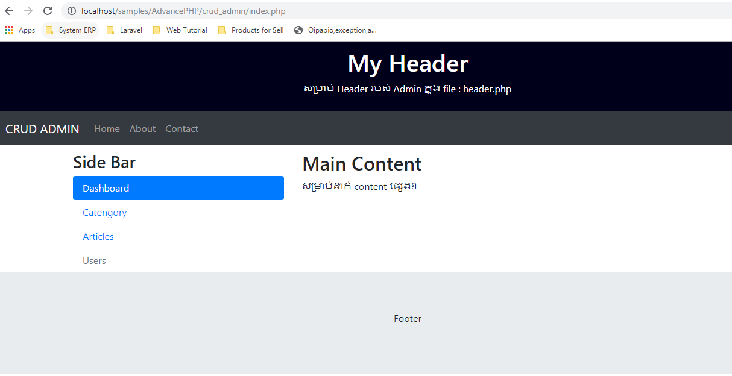

<!DOCTYPE html>

<html lang="en">

<head>

<title>Bootstrap 4 Website Example</title>

<meta charset="utf-8">

<meta name="viewport" content="width=device-width, initial-scale=1">

<link rel="stylesheet" href="https://maxcdn.bootstrapcdn.com/bootstrap/4.3.1/css/bootstrap.min.css">

<script src="https://ajax.googleapis.com/ajax/libs/jquery/3.4.1/jquery.min.js"></script>

<script src="https://cdnjs.cloudflare.com/ajax/libs/popper.js/1.14.7/umd/popper.min.js"></script>

<script src="https://maxcdn.bootstrapcdn.com/bootstrap/4.3.1/js/bootstrap.min.js"></script>

<style>

.fakeimg {

height: 200px;

background: #aaa;

}

</style>

</head>

<body>

<div class="jumbotron text-center" style="margin-bottom:0">

<h1>My Header</h1>

<p>សម្រាប់ Header របស់ Admin ក្នុង file : header.php</p>

</div>

<nav class="navbar navbar-expand-sm bg-dark navbar-dark">

<a class="navbar-brand" href="#">Navbar</a>

<button class="navbar-toggler" type="button" data-toggle="collapse" data-target="#collapsibleNavbar">

<span class="navbar-toggler-icon"></span>

</button>

<div class="collapse navbar-collapse" id="collapsibleNavbar">

<ul class="navbar-nav">

<li class="nav-item">

<a class="nav-link" href="#">Home</a>

</li>

<li class="nav-item">

<a class="nav-link" href="#">About</a>

</li>

<li class="nav-item">

<a class="nav-link" href="#">Contact</a>

</li>

</ul>

</div>

</nav>

<div class="container" style="margin-top:30px">

<div class="row">

<div class="col-sm-4">

<h3>Side Bar</h3>

<ul class="nav nav-pills flex-column">

<li class="nav-item">

<a class="nav-link active" href="#">Dashboard</a>

</li>

<li class="nav-item">

<a class="nav-link" href="#">Catengory</a>

</li>

<li class="nav-item">

<a class="nav-link" href="#">Articles</a>

</li>

<li class="nav-item">

<a class="nav-link disabled" href="#">Users</a>

</li>

</ul>

<hr class="d-sm-none">

</div>

<div class="col-sm-8">

<h2>Main Content</h2>

<p>សម្រាប់ដាក់ content ផ្សេងៗ</p>

</div>

</div>

</div>

<div class="jumbotron text-center" style="margin-bottom:0">

<p>Footer</p>

</div>

</body>

</html>